--1) Finding total revenue generated and total quantity purchased.
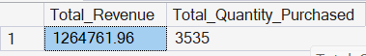

--2) Finding top 2 products with highest revenue and quantity purchased.
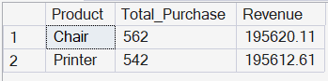

--3) Finding least purchased product with revenue.
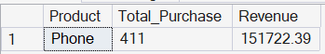

--4) Finding which referral source has generated highest revenue.
Also finding total orders by each referral source where Total price is greater than 1000.
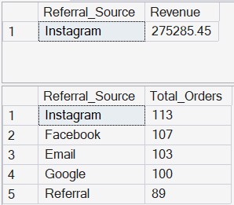

--5) Finding average quantity purchased by each product.
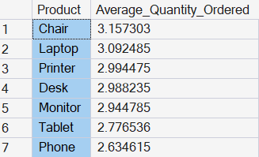

--6) Finding total numbers of Order placed and Order status.
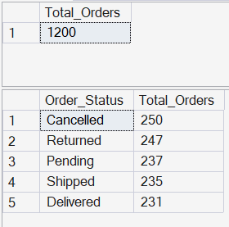

--7) Finding yearly sales and units.
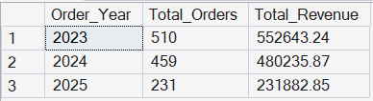

--8) Finding average unit price.
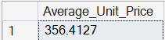

--9) Finding number of orders with 'No Coupon'
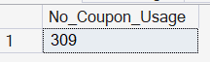

--10) Find the number of count of each payment method
